Shine Wealth Industrial Limited
Customer Manual

1. Become a member
If you are not a member，please click “Join” to enter the following page and input the required fields then click “Join” to submit.
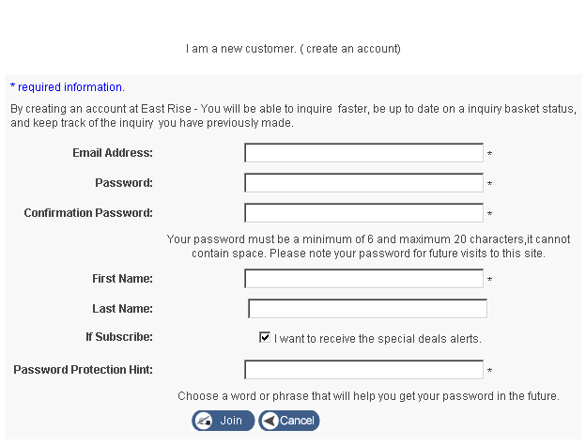
image 1

2. Login
If you are alreadly a member, please input your Email address and Password, please refer to the image 2, then click LOGIN to enter your page, you will see the similar image 3.
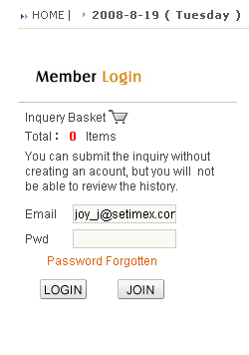
image 2
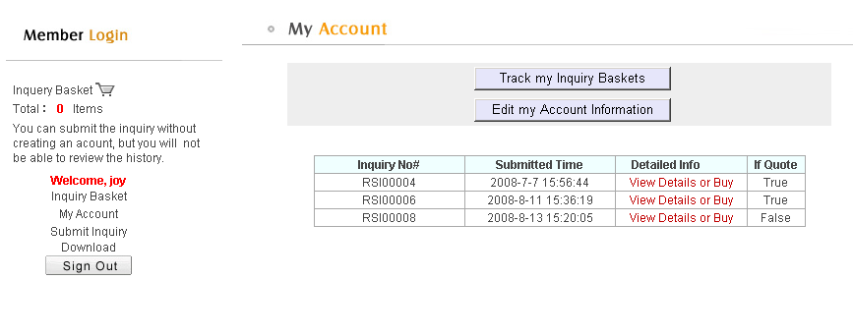
image 3

3. Inquire the Price
The inquiry steps as below, please see the image 4：
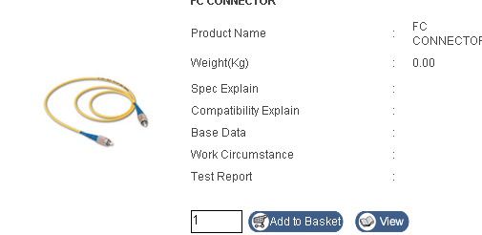
image 4
Please input the quantity and click “Add to Basket” to add the item into your inquiry basket。
If you want to view your inquiry basket, please click “View”, here you can see the page is similar as the following image 5.

4. View the Inquiry Basket
Please click the “Inquiry Basket” to view your inquiry basket。
The inquiry basket will show the items which you inquire but don’t submit. 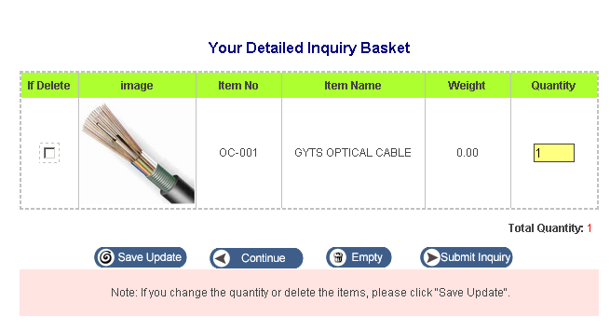
image 5

Note:
a. If you change the quantity or delete the items, please click "Save Update"..
b. If you want to go to the items list and continue to inquire, please click “Continue”.
c. If you want to delete all items from the inquiry basket, please click “Empty”.
d. If you want to submit the inquiry basket, please click “Submit Inquiry”.

5. Submit the Inquiry Basket
Please see the image 5 and click “Submit Inquiry”, you will see the following page,
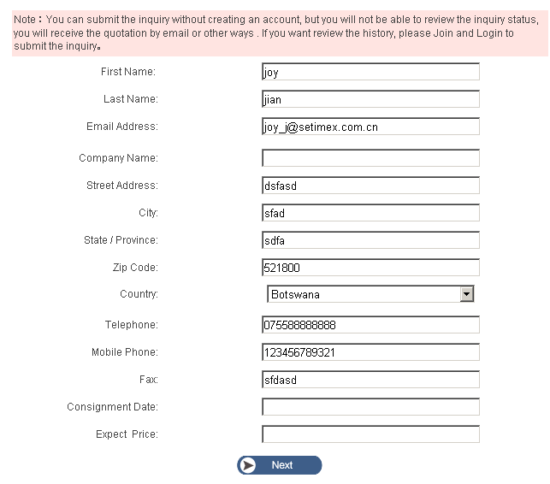
image 6

After you input the entire information, please click “Next” to enter the following page is similar as the image 7.
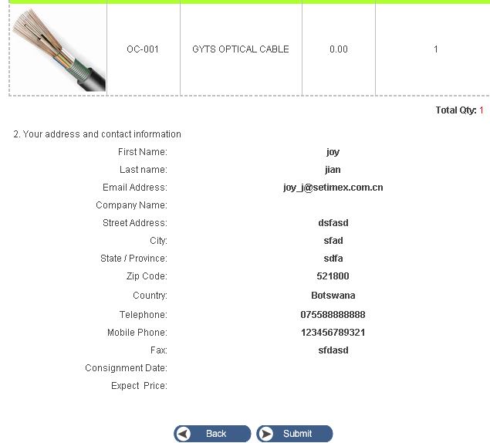
image 7

If you confirm the all information, please click “Submit” to do the last job, here you will see a welcome page is similar as the image 8, at the same time, you can receive an email to show your inquiry basket, please refer to the image 9.
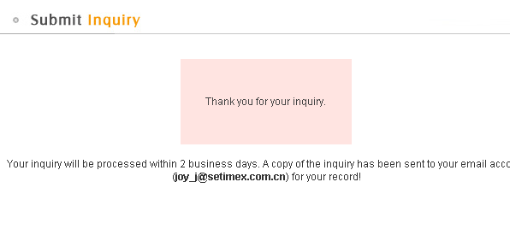
image 8
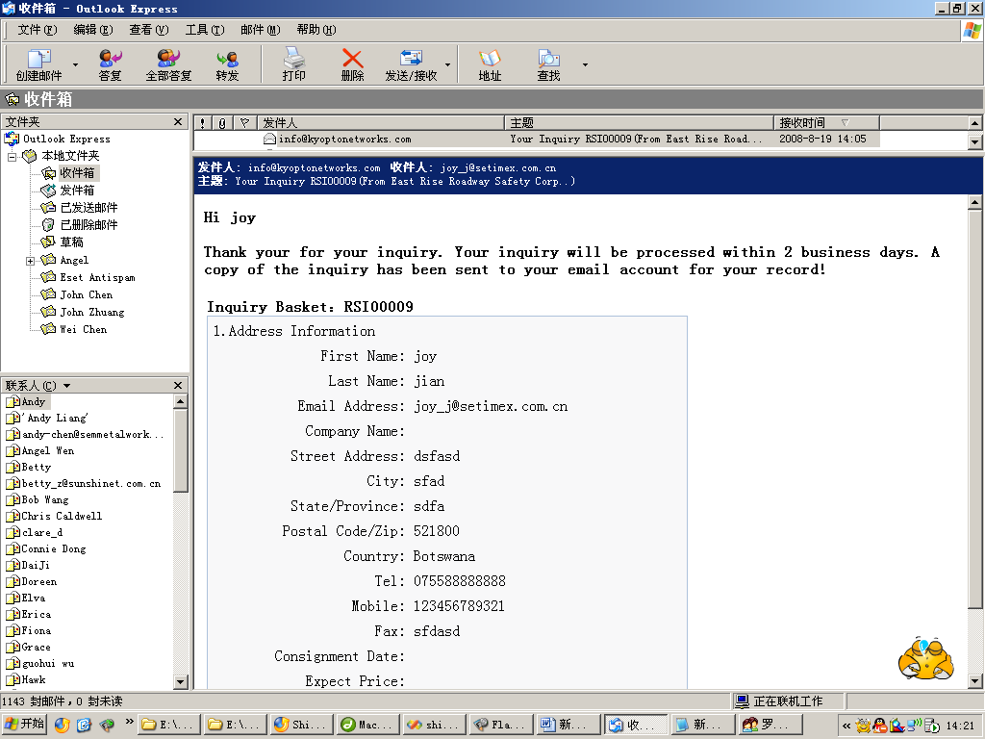
image 9

6. My Account
Please click “My Account” to view your information, you will see the following similar image 10.
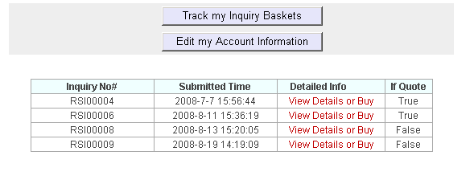
image 10

a. Submit a Purchase Order
Please click “View Details or buy” to view the detailed inquiry basket or purchase the items. Please refer to the image 11.
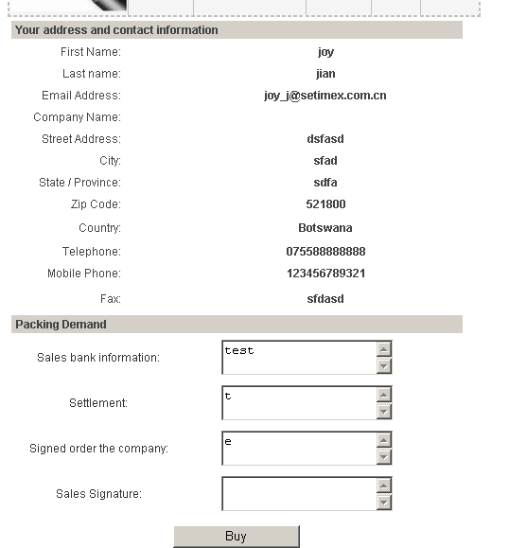
image 11

After you input all informatio, please click “Buy” to submit the purchase order.

b. Change the Account Information
If you want to change your account information, please click “Edit my Account Information” to modify your email address or name etc, please refer to the image 12.

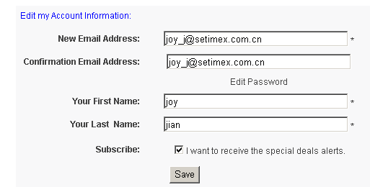
image 12

7. Nonmember submit a inquiry basket
You can submit the inquiry without creating an acount, but you will not be able to review the history. The step is similar as the member, only you need not login.

8. Download the product information and quotation documents (only for the members)
Please see the image 13.

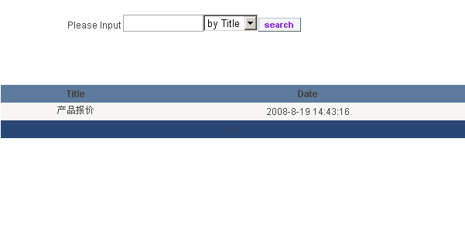
image 13

